**TASK 1:**

Using Genetic Algorithms to guess a password given the number of correct letters in the guess. Build a mutation engine

**CODE:**

*# Owned*

__author__ *=* "Qaiser Abbas"

__copyright__ *=* "Copyright 2020, Artificial Intelligence lab-10"

__email__ *=* "qaiserabbas889@yahoo.com"

*#===============================================================*

*# {code}*

*import* random

*import* datetime

*import* sys

*import* time

geneSet *=* 'abcdefghijklmnopqrstuvwxyzABCDEFGHIJKLMNOPQRSTUVWXYZ!. '

password *=* "Genetic Algorithm by Qaiser!"

*def* *generate_parent*(length):

    gene *=* []

*while* len(gene) *<* length:

        sample_size *=* min(length *-* len(gene), len(geneSet))

*# appends list with values ==> ['X','B'].extend('a','y') -> ['X','B','a','y']*

        gene.extend(random.sample(geneSet, sample_size))

*# converts list to str ==> ['a', 'b', ' ', 'C', 'N', 'x'] -> ab CNx*

*return* ''.join(gene)

*def* *get_fitness*(guess):

*return* sum(1 *for* expected, actual *in* zip(password, guess) *if* expected *==* actual)

*def* *mutate*(parent):

    index *=* random.randrange(0, len(parent))

    child_genes *=* list(parent)

    new_gene, alternate *=* random.sample(geneSet, 2)

    child_genes[index] *=* alternate *if* new_gene *==* child_genes[index] *else* new_gene

*return* ''.join(child_genes)

*def* *display*(guess):

    time_diff *=* datetime.datetime.now() *-* startTime

    fitness *=* get_fitness(guess)

*# print('{0}\t{1}\t{2}'.format(guess, fitness, time_diff))*

    time.sleep(.001)

    sys.stdout.write('\rGeneration #' *+* '\t' *+* guess)

*if* __name__ *==* '__main__':

    random.seed(4)

    startTime *=* datetime.datetime.now()

    best_parent *=* generate_parent(len(password))

    best_fitness *=* get_fitness(best_parent)

    display(best_parent)

*while* True:

        child *=* mutate(best_parent)

        child_fitness *=* get_fitness(child)

        display(child)

*if* best_fitness *>=* child_fitness:

*continue*

*if* child_fitness *>=* len(best_parent):

*break*

        best_fitness *=* child_fitness

        best_parent *=* child

**OUTPUT:**

**Generating Password:**

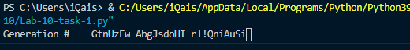

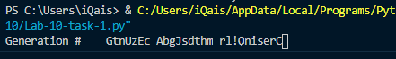

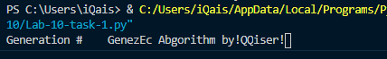

**Password Generated:**

